

Exploit It Technologies: Business Plan

Technology Business Plan Design – FALL 2015

FACC 500

-Professor Michael Avedesian -

Term Project

|  |  |
| --- | --- |
| Name | McGill I.D # |
| Rafic Osseiran | 260454187 |
| Miao Zhao | 260501319 |
| Dante Filice | 260507857 |
| Justin Hawrysh | 260401419 |
| Ammar Raufi | 260504960 |

*Submitted on* ***Tuesday****,* ***November******17th******2015***

Table of Contents

1 Introduction 1

1.1 Mission Statement 1

2 Our Technology, the Opportunity and the Value Proposition 2

3 The Product Roadmap 2

3.1 Business Model 3

3.2 Development Strategy 5

3.3 Marketing Strategy 6

3.3.1 Consumer Profile: Segmentation and Targeting 6

3.3.2 Market Profile: Situation/Market Analysis 7

3.4 Growth & Long-term Goals 7

4 Appendix 9

# Introduction



The world we live in today comprises of a constantly and rapidly changing technological landscape that allows people in developed countries the means to have access to portable electronic devices such as smartphones, mp3 players, and laptops. The frequent use of such devices has also been rapidly increasing over the years. Taking the smartphone as an example, a survey of American smartphone owners showed that 72 % of them check their phones at least once an hour, most of them even several times[1]. This has resulted in one of the biggest challenges for smartphone manufacturers as they are struggling to improve battery life, while smartphones are becoming thinner and lighter than ever. Numerous solutions to the poor battery life have been developed such as portable battery packs and chargers; however, consumers mainly find them inconvenient and having to charge the portable battery packs and chargers in order to charge their mobile phones can be seen as a burden. On the other side of the spectrum there are people in developing countries that are not living in the same technological bubble as those in developed countries and do not even have a steady and reliable source of electricity.

## Mission Statement

Exploit It Technologies aims at finding innovative business engineering solutions to problems such as those aforementioned by exploiting green, renewable and sustainable resources that would otherwise be overlooked. We hope to supply the world with a more convenient, cost-efficient and eco friendly source of energy that (a) offers a better solution to the current battery crisis portable electronic users are facing in developing nations, and (b) offers people in non-developed and developing countries a decent source of electricity.

# Our Technology, the Opportunity and the Value Proposition



Our solution is to harness and store the energy an individual expends when walking, running or doing any physical activity by creating a sole insert that may be placed into any shoe or onto any sandal. The product, called PowerSole, would consist of a sole insert with a tiny air cushion that pumps air into a micro-generator once compressed by a person’s foot. This air will then flow through a tiny tube into a micro-turbine to generate power. The power is stored in a tiny battery pack that can be clipped onto the side of the shoe or on top of the laces. The battery pack may be removed at any time to power any device through a USB cable. Refer to **Exhibit 1** for more detail. The opportunity presents itself through the growing interest in sustainable and renewable forms of energy. It is our belief that there is a large market that will be interested in doing their own part in creating their own clean form of energy.

PowerSole can be used to satisfy a need that the average person in the present time has all too often, charging their portable devices. It is useful for;

* People performing outdoor activities involving running and hiking to transform the energy they lose into clean and useful energy
* Situations when people have no other way of charging their portable electronic devices
* Helping environment conscious people do their small part in ensuring a sustainable future

# The Product Roadmap



The product roadmap (see **exhibit 2)** shows the product lifetime cycle, from inception to major release, of PowerSole, our micro-turbine shoe power generator. The roadmap is split into three main sections by release date (all preliminary and expected to change). Firstly, the alpha release is expected to come around February 22nd. Secondly, the beta release is expected to come out around April 25th. Finally, the major release is expected around August 1st. The roadmap is an oversimplification of our production process in order to demonstrate our continual experimentation and adaptation. These releases are meant to show how we will constantly be changing our product to suit what we determine to be the market need. In reality, we expect a more continuous production and learning loop with new features constantly being added and tested on customers. Production might be done in sections to save on manufacturing costs but will be done in small batches and carried out as soon as possible in order to get the product into the hands of our target customer and get us needed updates on our progress.

Our approach for PowerSole starts with general market research to determine the need for our product and who our early adopters are likely to be. Once identified, early adopters will be brought into a testing facility and used to identify features necessary for the alpha product. After these features have been selected, work will begin on a minimal viable product (MVP). Upon completion, the MVP will be released to early adopters and their response will be gauged, measured, and used to create an improved product. This process is the build-measure-learn feedback loop and is outlined further in the development strategy section. It will be repeated constantly over the lifetime of the product. This roadmap is designed to have an alpha and a beta preliminary product releases but will likely be adjusted as business starts to have many more releases as features are updated and reworked.

## Business Model

We will start with the development of our shoe sole micro-turbine personal energy generator called PowerSole. This product is a cushioned sole, which can be inserted into most retail shoes and charges a battery when walked on. We decided to create this product as a sole insert so we would not have to enter the very competitive shoe industry and compete with large, established brands. Not creating an entire shoe also greatly reduces design complexity and allows our customers to use existing, high performance shoes with our product. Our shoe insert will be designed to work with most existing shoes on the market so we will be able to operate outside the shoe market and instead create a new niche in the portable electronics market.

We will outline the features and specifications of PowerSole with the help of our early adopters and create an initial alpha model that we estimate could cost around $45 to make (refer to **exhibit 3** for costs). This model will be sold to the early adopters at a price of $100. This price point was chosen because competitor products tend to be around $200 and the lower pricing makes more sense since it is sold as a shoe insert so the purchase of a shoe is also necessary.

We will use feedback from our alpha release to decide what direction to go with the beta release (whether to pivot or persevere). Once our beta release has been defined, we expect a larger release at a lower cost point of around $37.50 per PowerSole. The beta release will also come at a price point of around $100 and will be distributed to specialty hiking or jogging retail stores. Our company will also debut PowerSole at various long distance races or other outdoor competitions. We will attempt to locate the opinion leaders of running/hiking/outdoor groups and offer them our product to buy or test. We expect PowerSole to spread by word of mouth and eventually carve its own niche in the developing market of wearable technology. As we keep updating and improving our product, we expect our sales to grow and our production to increase. As long as no large pivot or technology change is required, this should reduce our cost per product to what we think could be around $28.50. If we continue selling at our $100 price point, this leaves a large profit margin for growth and ongoing research and development.

Our company will continually work to run important experiments throughout the lifetime of PowerSole to keep this product updated and valuable to the consumer. The current plan, outlined above, calls for a few main updates or pivots but, in reality, will be made up of many smaller changes and experiments.

## Development Strategy

Our first step will be to use the licensed technology to develop our MVP and use that as a baseline and track progress from that standpoint. As part of our development strategy we plan to measure the metrics that will yield valid and useful information for us to measure PowerSole’s progress. We will accumulate data from the first learning milestone and evaluate the following key actionable metrics: Type of shoe worn with PowerSole (i.e., sneakers, sport shoes, casual wear), gender, age group, number of sales in urban vs. rural areas and the amount of refunds demanded / reason for refund.

Throughout the startup stages of launching our product we will focus on consistently and quickly reacting to our customers’ feedback to ensure continuous optimization, and thus customer satisfaction. The data measured through the Build-Measure-Learn loop will be regularly taken into consideration. Also, at different stages, and always according to data analysis, we will need to decide whether to pivot or persevere our strategy and fix new objectives. Out of the many forms of existing pivots, we believe that two are the most relevant.

First, we could potentially implement a “zoom out” pivot. In fact, the whole concept of converting otherwise wasted energy to useful forms could be implemented in many different ways in the future at much larger scales. Second, we might use a “technology pivot”, thus acquiring new technology to further expand our products. The new potential technologies could be related to the development of the geothermal thermoelectric household power generation system.

From the Lean Startup’s ways to drive sustainable growth, we have identified two modes that would be useful. The first is word-of-mouth, which relies on customer satisfaction. The satisfied users will introduce their friends and family to PowerSole. The second is through advertising. In this case, we plan to use the major sporting outlets with whom we will be partnering to advertise the use of our sole. The paid and the sticky engines of growth are most relevant to PowerSole. These two engines of growth are what we ultimately wish to attain; the paid engine will be necessary and will serve us in attracting new customers while the sticky engine will retain these users and encourage them to use our product.

## Marketing Strategy

### Consumer Profile: Segmentation and Targeting

Our target consumer section would be those who not only wear shoes and possess portable electronic devices, but also are environmentally conscious. Ideally our customer would feel happy to charge their own electronic devices with energy generated by themselves and 100% clean. Evidently our potential customers would not rely on our product as a primary method to charge their devices, but they would feel the sense of achievement, a feeling of contributing to a cleaner environment by using this product. People enjoy hiking or any outdoor activities involve a significant amount of walking may also be attracted to our product, as when they are out in the field it might be hard for them to charge their personal electronic devices due to the lack of available of charge station. By using our product, they can charge directly from their shoes.

In order to attract new customers, we would rely on our early adopters and early majority to spread the word. We would first locate those opinion leaders within each outdoor group. After giving samples to those opinion leaders we hope they could penetrate these groups and turn their members into our users. We wish to use this marketing method because people generally pursuit outdoor activities in small groups. In this way we could reach our target customers fast.

We also plan to partner with various specialty sporting outlets across the country to promote and advertise PowerSole. This will really help in bringing our product to the mainstream and make it visible to more people.

### Market Profile: Situation/Market Analysis

The market size of portable consumer electronics in North America in 2015 is 262.1 million dollars. This market is also growing in the future, with estimated sales of 290 million dollars in 2017. In 2012 around 50% of American people participated in outdoor recreation, resulting in 141.9 million people. As a result, the total market size for our product, PowerSole, would be estimated as 50% * 262 million dollar equals 161 million dollars a year. We believe that our product will enable us to capture a new niche of the total market. The newly created field of product would then attract a broader generation of people into using our product in the future (refer to **exhibit 4A** and **exhibit 4B** for details). **Exhibit 5** summarizes our marketing and development strategies.

## Growth & Long-term Goals

Our company has long-term plans of bringing our product, PowerSole, to developing countries. Once we have established our shoe sole insert in the running/outdoor market we plan on creating a more robust, simple version and starting sales in developing countries. We believe there is a very large market for this technology in developing countries because of the lack of access to continuous, reliable electricity in many countries around the world. Our product would provide a dependable method to obtain electricity for small electronics such as cell phones, flashlights, GPS devices, personal water purifiers, etc. We feel this is the ultimate goal; allowing people of these nations to take advantage of the energy around them. Until then, we are introducing, iterating and optimizing our product in the developed world. Once we have been established in the developed world, we are planning on bringing in more technology to help utilize this “free” energy. This is the future of Exploit It Technologies, implementing clean power generation on a small scale.

We believe that small-scale power generation is the key to utilizing renewable energy sources. Our next step with making small-scale energy sources will be on the residential scale. We have been researching and developing a geothermal thermoelectric household power generation system. This system creates power by a temperature difference between the ambient atmosphere/solar radiation and the constant temperature 15-20 ft. below the surface. Since the temperature 15-20 ft. below the surface is relatively constant throughout the year, there is always a temperature difference between the ambient atmosphere and the ground. The thermoelectric generators convert the temperature difference into electrical power through heat transfer. Research and simulations have shown that a small model (small meaning it would fit in a small closet) could create up to 3kW of power. This would target customers living in temperate climates. Temperate climates are climates whose temperatures vary greatly throughout the year, hot summers and cold winters (like here in Montreal). The beauty of his system is that the magnitude of the power output is proportional to the temperature difference. This is a perfect fit for the growing power demand during very hot summer days to run air conditioners, and very cold winter days to run heaters.

# Appendix



**Exhibit 1[2]: Possible prototype models and uses**

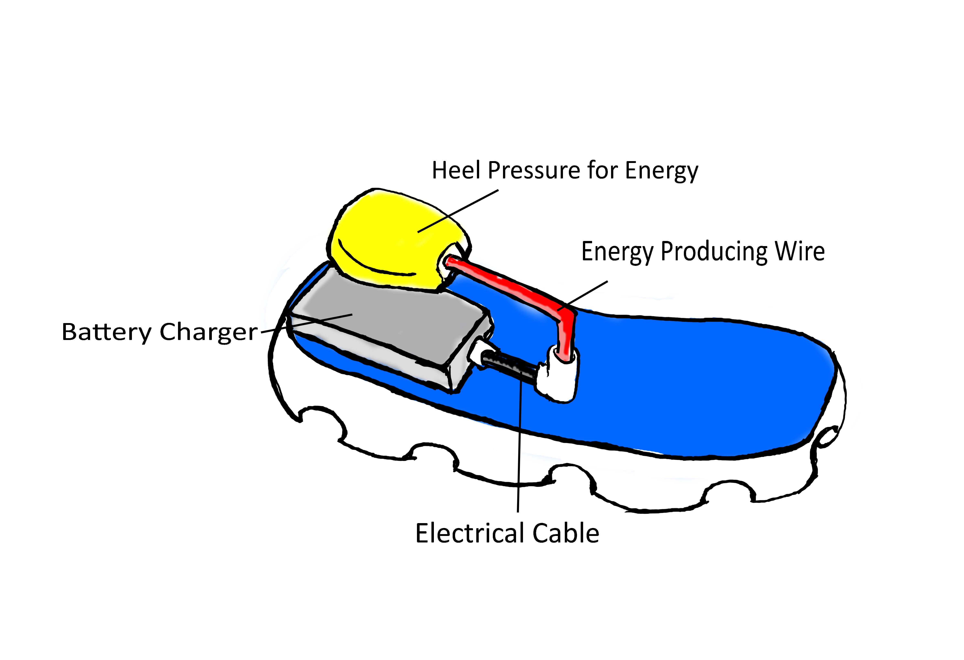

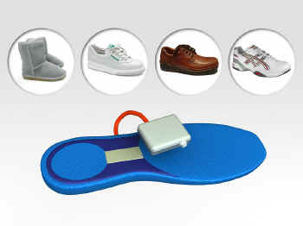

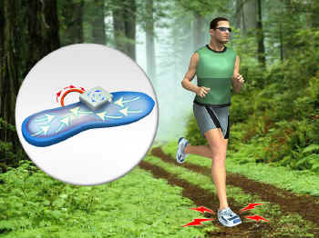

**Exhibit 2: The Product Roadmap**

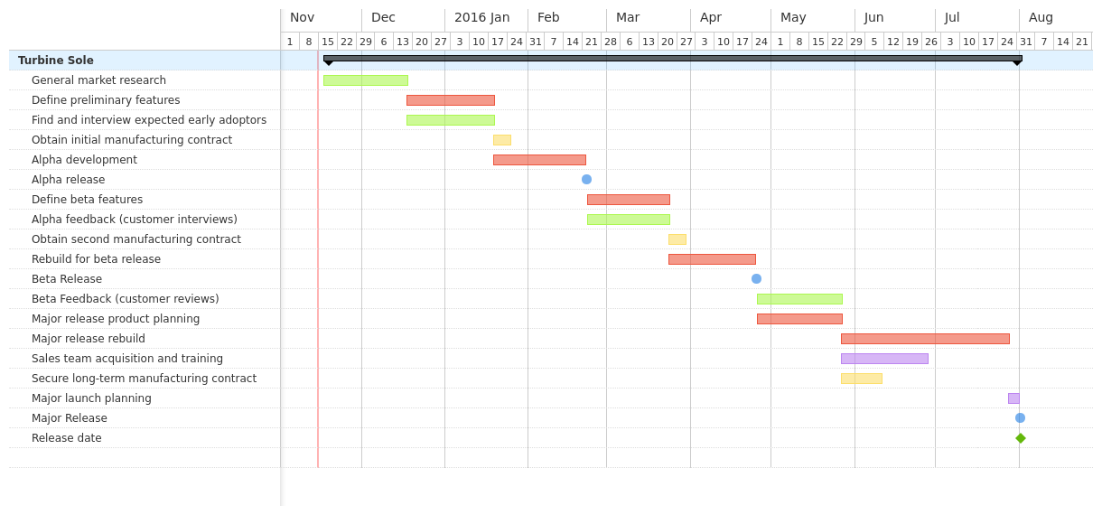

* Green represents market/product research
* Red represents product development/construction
* Yellow represents manufacturer acquisition
* Purple represent marking strategy
* Blue represents product releases

**Exhibit 3:** Projected Product Costs Per Product (Manufacturing costs accounted for in material prices):

|  |  |  |  |
| --- | --- | --- | --- |
|  | Alpha Release | Beta Release | Major Release |
| Micro-turbine | $10 | $9 | $7 |
| Sole (outside) | $5 | $4 | $3 |
| Sole (inside) | $8 | $7 | $5 |
| Hosing | $2 | $1 | $0.50 |
| Battery | $5 | $4 | $3 |
| Charging Electronics | $15 | $12.50 | $10 |
| **Total:** | **$45** | **$37.5** | **$28.50** |

E**xhibit 4A[3] Portable electronic devices market in North America, unit in Million (USD)**

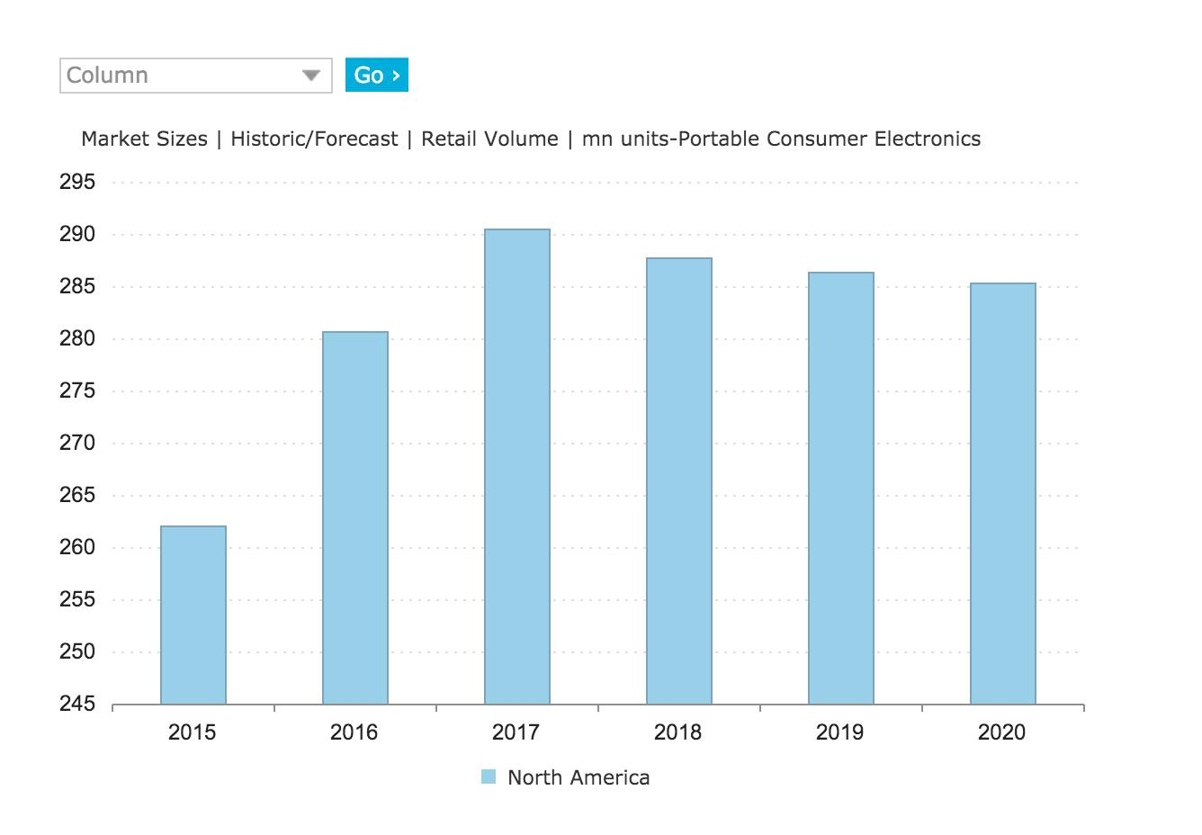

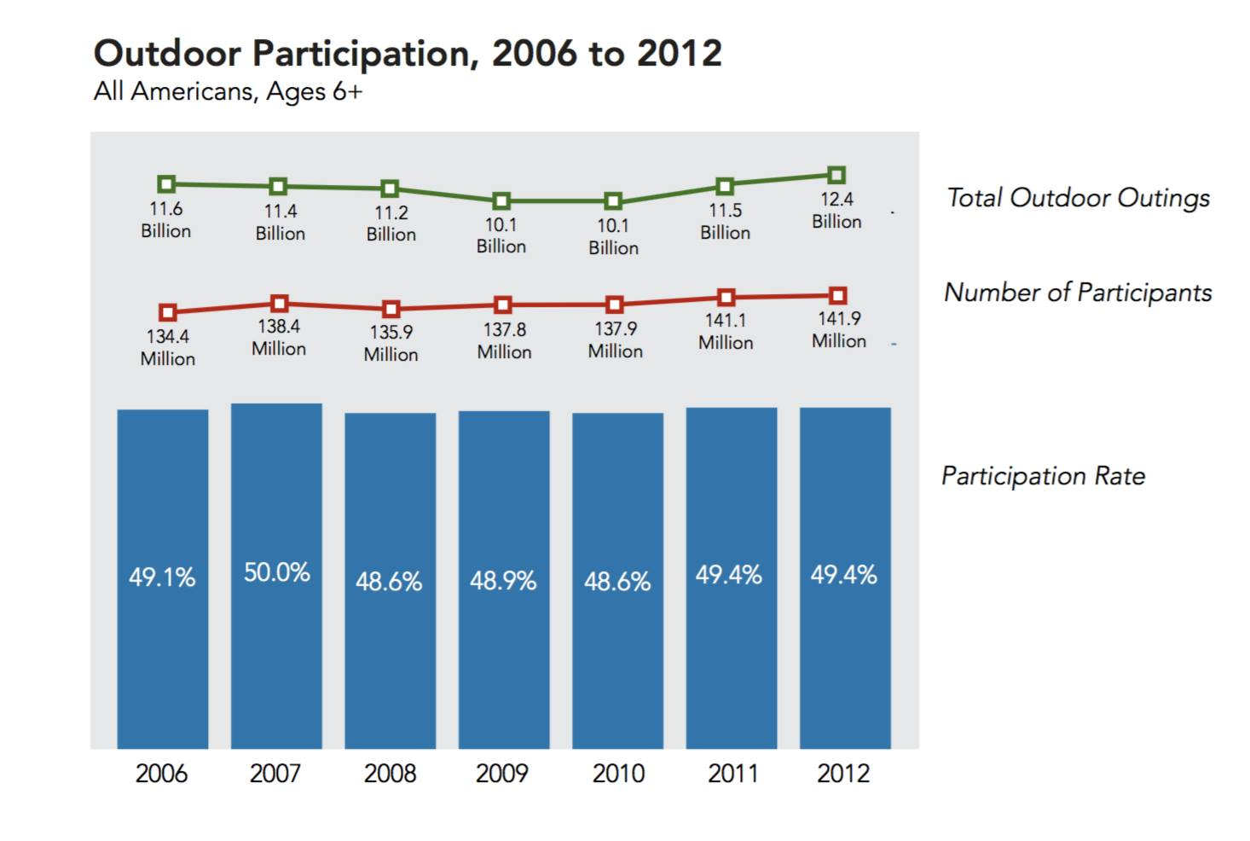**Exhibit 4B[4] Historical data for American people involvement in outdoor activities**

**Exhibit 5 Summary of Marketing and Development strategies**

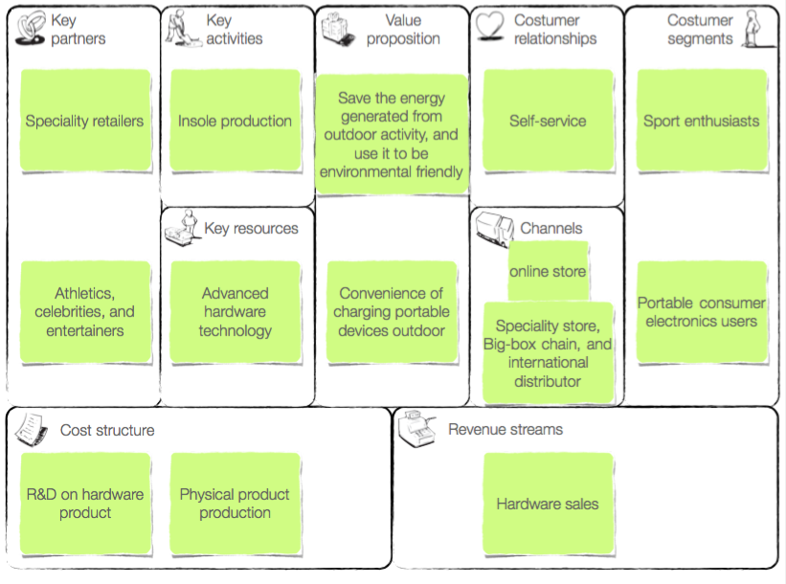

# 

1. http://www.statista.com/chart/3666/frequency-of-smartphone-usage/
2. Adapted from http://www.marketlaunchers.com/almeyda2.htm
3. Euromonitor international Passport GMID database
4. Outdoor Participation report 2013 by outdoor foundation